Class Work – Week5 – Vulkan Intro

Muhammad Sabeeh

Contents

Setting up the Dev Environment: 1

Checking Pre-reqs: 1

Device: 1

Experience with C++: OK 2

Compiler with C++17 features: 2

See the Ubisoft NEXT to get an appreciation of opengl: 3

See the Direct3D samples to get an appreciation of Direct3D: 4

# Setting up the Dev Environment:

## Checking Pre-reqs:

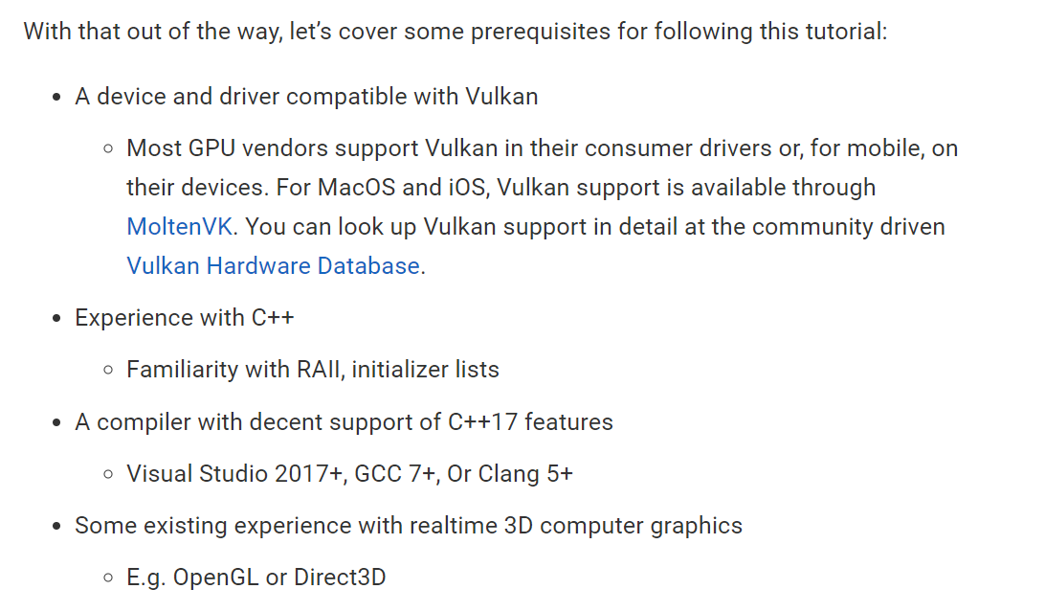

### Device:

Run ‘**dxdiag**’ and take snapshot of the Display page with GPU. For me it’s the following:

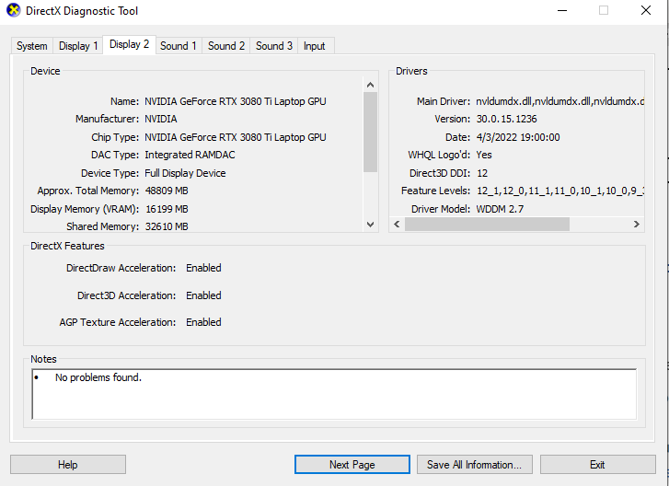

### Experience with C++: OK

### Compiler with C++17 features:

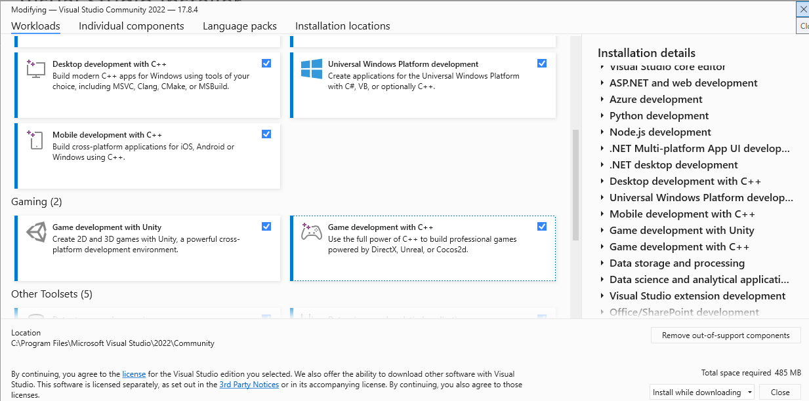

Some exp. With OpenGL and/or DirectX3D:

A little tricky.

### See the Ubisoft NEXT to get an appreciation of opengl:

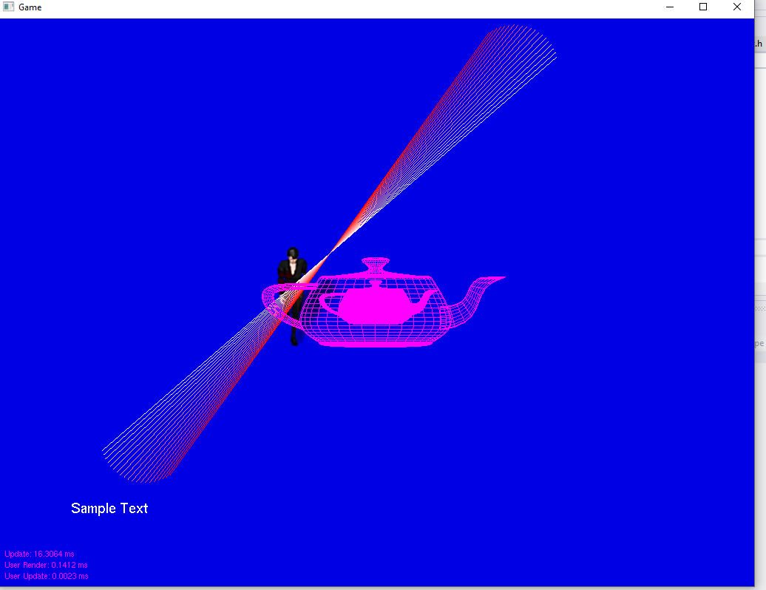

### See the Direct3D samples to get an appreciation of Direct3D:

#### Go to d3dcoder.net:

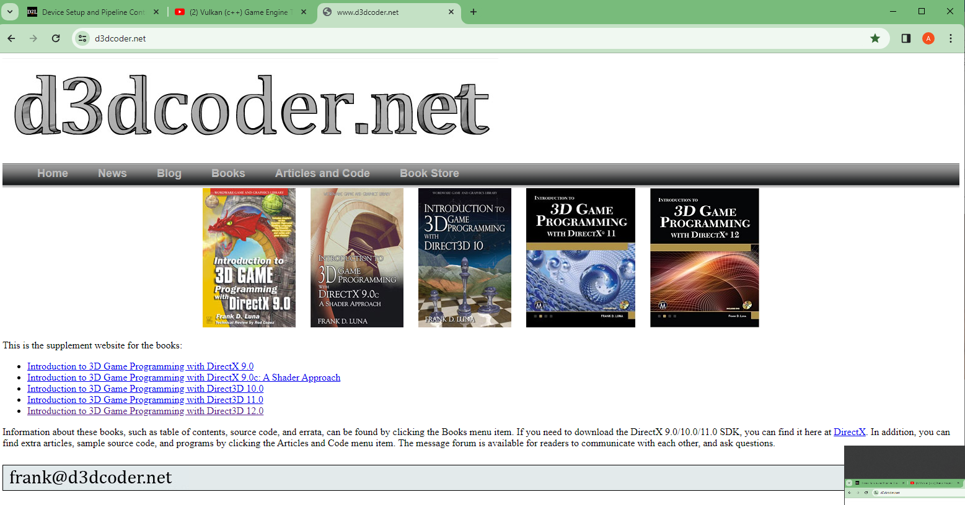

#### Download the code for D3D 12:

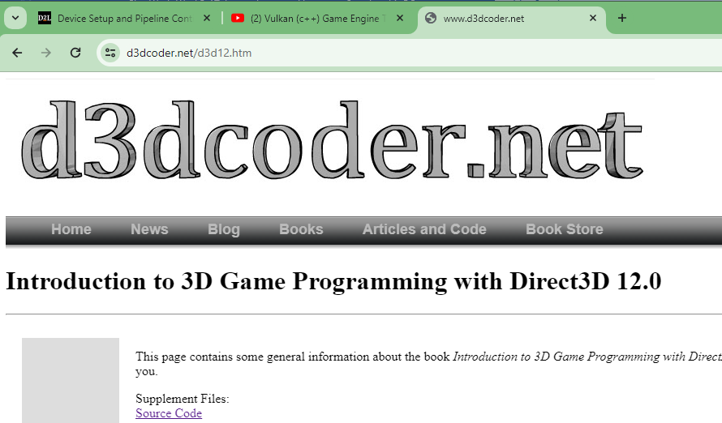

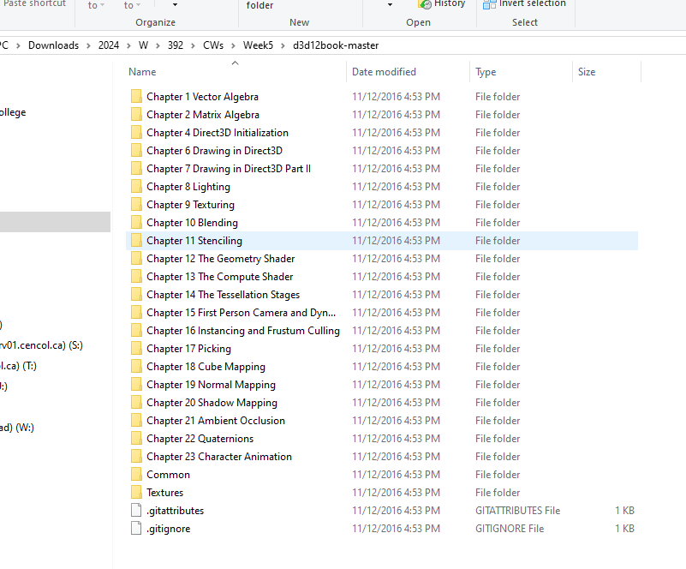

#### Explore the solutions:

(Each chapter comes with a solution .sln file, open it in VS and run it. For example, last chapter shows animations at work)

